Participant Sign-up Form: Everyone Can Dance - Online (for organisations only)

**Please complete this sign up form in order to access Everyone Can Dance (online).**

Move Momentum's Everyone Can Dance (online), is funded by The Hampshire Active Health Programme, which provides one off grants to organisations working to encourage and provide physical activity opportunities in communities facing the biggest health inequalities.

This programme is managed by Energise Me, on behalf of Hampshire County Council, with funding provided by the Contain Outbreak Management Fund (COMF) from the Department of Health and Social Care.

**Important:** By completing this form, you understand and give consent that all anonymised data will be shared with Energise Me, Hampshire County Council and our evaluation partners to undertake a measurement and learning exercise of the individual projects and the Hampshire Active Health Programme as a whole. They will publish reports and learning based on the data, but no individual will be identified without further explicit consent. In some cases, participants may be asked to provide non-anonymised feedback including the use of image and video – in these cases full permissions will be sought.

* Indicates required question

1. *Today's Date:

2. *Full Name:

3. *Postcode:

4. *Age:

5. *Do you identify with any of the following statements? *Tick all that apply.*

* A Carer
* An Activity Coordinator
* An Older Person (55+) who does less than 30 minutes of physical activity per week
* Having a BMI of 30+
* Having low or no income
* From Black, Asian, or ethnically diverse community
* Having a disability
* Having a long-term health condition

6. *Level of confidence in your ability to take part in physical activity 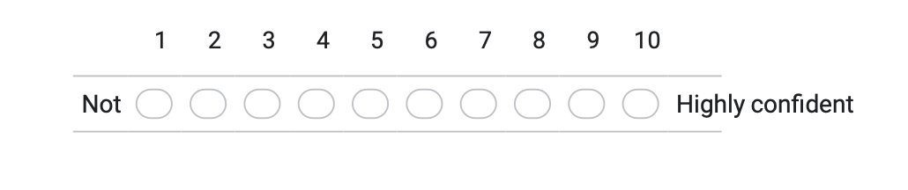

7. *What motivates you to join an Everyone Can Dance - Online session?

_____________________________________________________________________________

_____________________________________________________________________________

_____________________________________________________________________________

8. Organisations Name (if applicable)

_____________________________________________________________________________

**Exercise Disclaimer:**

Although great care and consideration has been taken to ensure the exercises in this programme are suitable for the desired audience. If you choose to participate you do so at your own risk and acknowledge that the exercises carry an inherent risk of physical injury if not performed correctly. Especially if you have a history of health problems or previous injuries. To the extent permitted by law, Move Momentum disclaim any and all liability in connection with the exercises, instructions or advice given within our programme Everyone Can Dance (online).

**Feedback Requirement:**

I agree to provide Move Momentum with additional feedback on the Everyone Can Dance (online) program when contacted. I give consent for this form and future feedback on the project to be shared anonymously with Energise Me, Hampshire County Council, and their evaluation partners.

* *I have read, understood and accepted the Exercise Disclaimer and Feedback Requirement.